**Employee Management System Overview**

The Employee Management System (EMS) is a web-based application designed to streamline the process of managing employees within an organization. It provides administrators with the tools they need to efficiently handle employee data, including personal information, work history, and performance evaluations.

**Features:**

1. **Home Page:**
   * Upon accessing the application through localhost:4200, users are directed to the Home Page.
   * The Home Page serves as the entry point to the EMS.

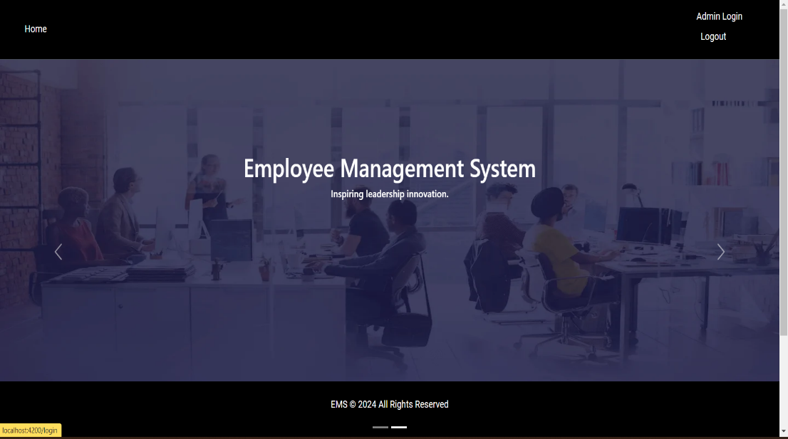

1. **EMS Page:**
   * From the Home Page, users can navigate to the EMS Page.
   * The EMS Page is the central hub for managing employee-related tasks and data.

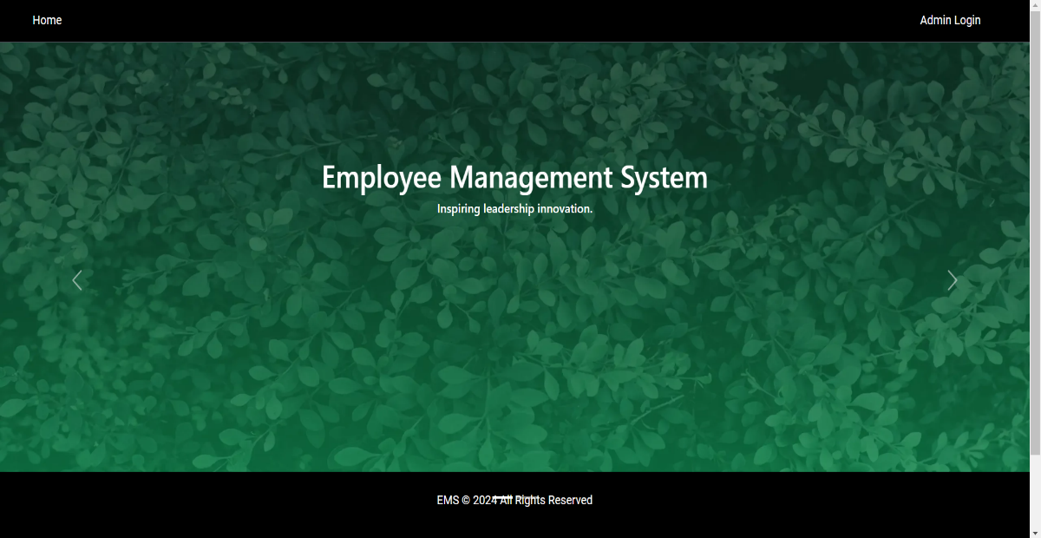

1. **Login Functionality:**
   * Located in the top right corner of the EMS Page is the Login section.
   * Users can enter their credentials, including email ID and password, to access the system.
   * Additionally, the Login page offers options for registering a new user and resetting a forgotten password.

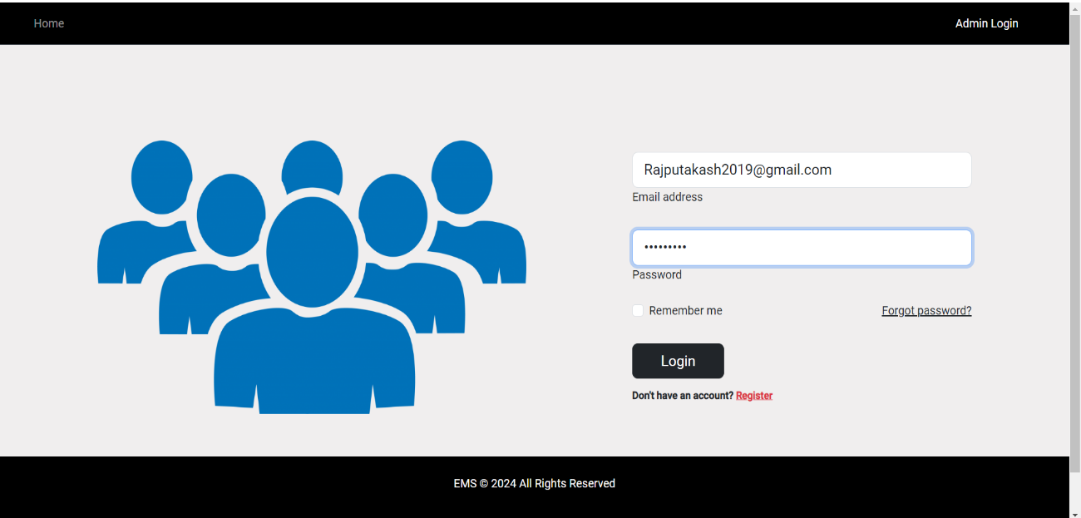

1. **User Authentication:**
   * Upon entering valid credentials, users can check a checkbox to authenticate their login.
   * Once authenticated, users gain access to the EMS functionalities.
2. **Employee List:**
   * Once logged in, users can view the list of employees registered within the system.
   * The Employee List provides a comprehensive overview of all employees and their details.

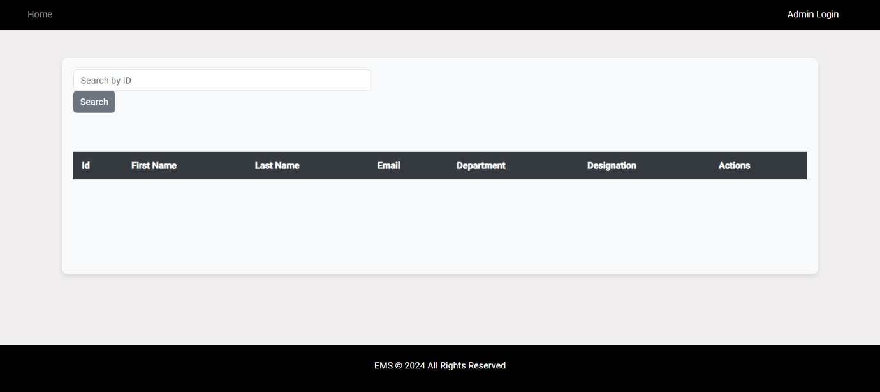

1. **Employee Management:**
   * Users have the ability to manage employee details directly from the EMS interface.
   * This includes updating personal information, work history, and other relevant data.
2. **Registration Page:**
   * Accessible from the Login Page, there is a Registration Page for new users.
   * Users can register new employees by providing necessary details and creating login credentials.

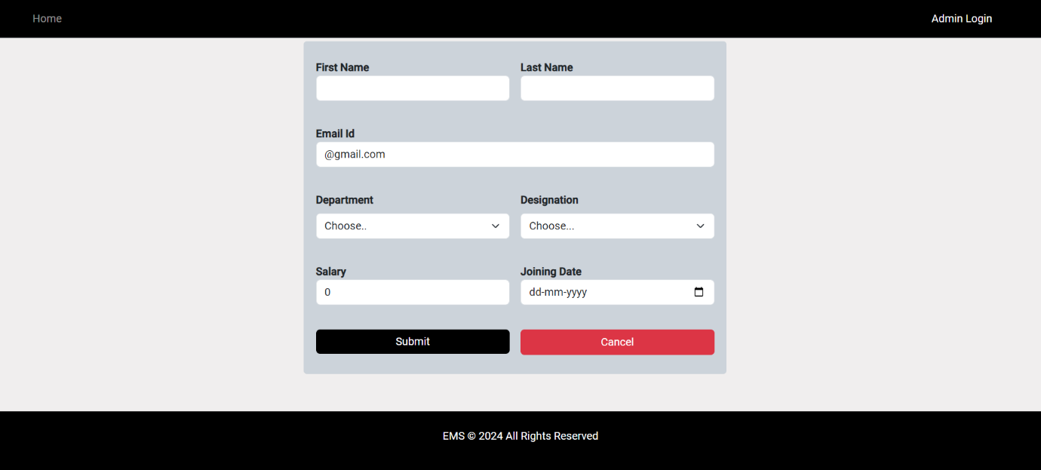

1. **Forgot Password Option:**
   * Also available on the Login Page is the Forgot Password option.
   * Users who forget their password can initiate a password reset process by entering their registered email ID.
   * Upon providing the correct email ID, users receive instructions to reset their password.

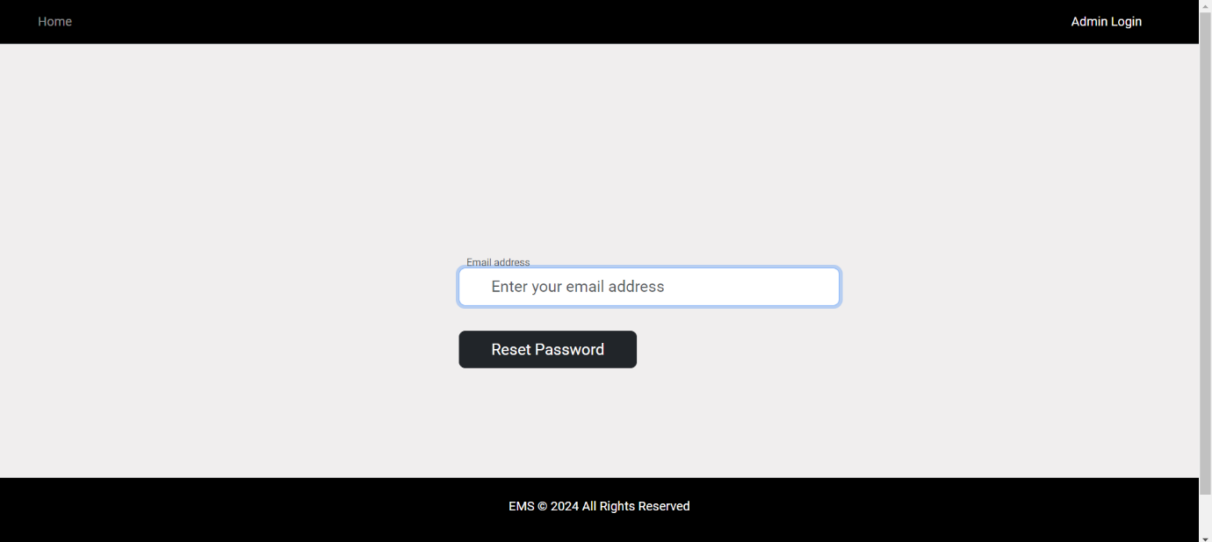

**Conclusion:**

The Employee Management System (EMS) provides a user-friendly interface for administrators to efficiently manage employee data. With features such as user authentication, employee list management, registration, and password recovery, the EMS simplifies the process of overseeing and organizing workforce information within an organization.